program 1:

import java.util.*;

class p1{

public static void main(String[] args) {

Scanner sc=new Scanner(System.in);

double wage=sc.nextDouble();

int hours=sc.nextInt();

int weeks=sc.nextInt();

double tot=0.0;

if(hours>40){

tot=(40*wage)+(1.5*(hours-40)*wage);

}

else{

tot=hours*wage;

}

if(hours<20){

tot=tot*0.1;

}

double salary=tot*weeks;

System.out.println("salary:"+salary);

}

}

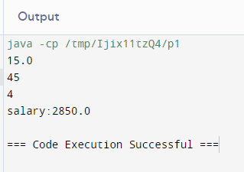

Program 2:

import java.util.*;

public class p2{

public static void main(String arg[]){

Scanner sc=new Scanner(System.in);

String t=sc.nextLine();

int n=sc.nextInt();

double tot=0.0;

switch(t){

case "Regular":

if(n>10){

tot=n*50*0.90;

}

else{

tot=n*50;

}

break;

case "Vip":

if(n>5){

tot=n*100*0.85;

}

else{

tot=n*100;

}

break;

case "Premium":

if(n>3){

tot=n*150*0.80;

}

else{

tot=n*100;

}

break;

default:

System.out.println("Invalid input");

return;

}

double a=tot;

if(tot<200.0){

a=tot-20;

}

System.out.println(a);

}

}

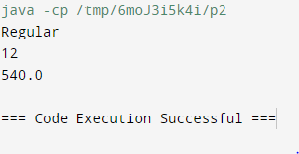

Program 3:

import java.util.*;

public class p3{

public static void main(String arg[]){

Scanner sc=new Scanner(System.in);

int n=sc.nextInt();

int l=Integer. MIN_VALUE;

int s=Integer. MAX_VALUE;

while(n!=0){

int d=n%10;

if(d>l){

l=d;

}

if(d<s){

s=d;

}

n/=10;

}

System.out.println(s+" "+l);

}

}

